# Department of Computing

# CS114: Fundamentals of Programming

# Class: BESE 11 B

# Lab 04: Conditional Statements and Iteration

# Date: November10th 2020

# Time: 02:00pm -05:00pm

# Instructor: Dr Hashir Kiani

# Lab Engineer: Ms Sara Mehmood

# Lab 04: Conditional Statements and Iteration

**Introduction**

If/else statement is a basic decision-making statement in programming. It executes one block of statements when the condition is true and other when it is false. In any situation, one block is executed and other is skipped. Loops are used to execute a block of code a certain number of times or until a condition is met.  
  
**Objectives**In this lab the students will learn and practice to develop the understanding of python conditional statements and loops.

**Tools/Software Requirement**Python IDLE **Description**

Follow the lab manual step by step. As you proceed, you will be asked to add screenshots/snaps of your results inside the provided output windows within this manual for grading purposes.

**Comparison/Relational Operators**

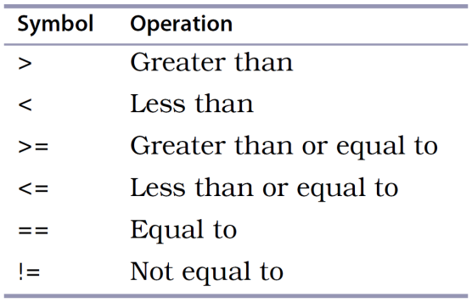

**Conditional Statements:**

Conditional statements perform different computations or actions depending on whether a specified condition evaluates to True or False. It uses the “if” keyword to check the condition. The condition of the “if” statement ends with a colon ( : ). The “elif” (short for Else-If) keyword can be used together with the “if” keyword to check additional conditions if the first “if” condition is False. Finally, if you want to execute a set of statements when no condition is True you can use the “else” keyword. See the example below for a clear understanding of the “if-elif-else” statement.

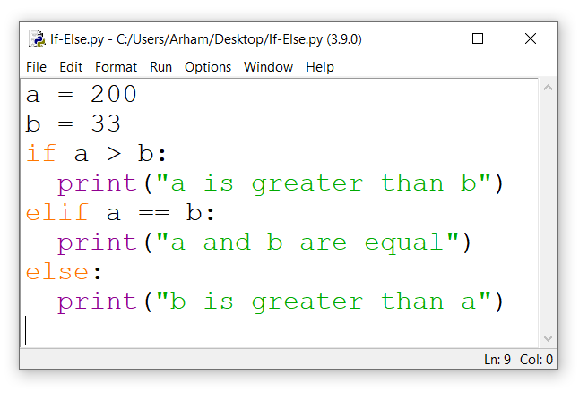

You can use multiple “elif” keywords with the “if” keyword as shown in the following example.

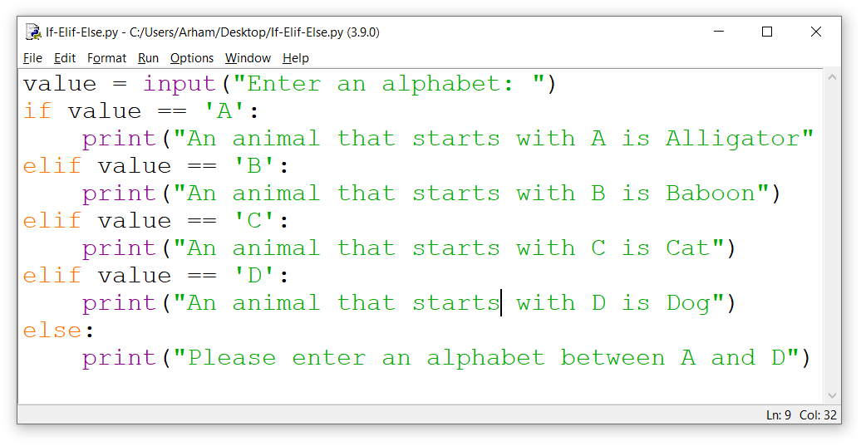

All statements that you want to execute when the condition is True should be written with a single Indentation.

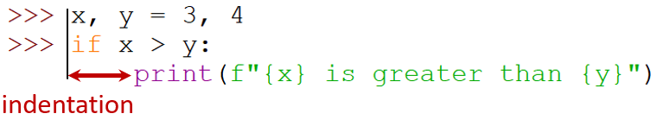

**Iteration**

Iteration or looping is used to execute a block of times a certain number of times or until a condition is met. The “for” or “while” keywords are used for iteration. The “for” loop is used when we want to execute a block of code a certain number of times. The “while” loop is used when we want to execute a block of code until a condition is met. See the example below for a clear understanding of the “for” loop.

for i in range(10): # This statement executes the indented block of code 10 times.

print(i)

else:

print(“The loop has ended”)

See the following example for a while loop.

i=0 # for a while loop you need to initialize your conditional variable

whilei<10: # This statement executes the indented block of code until the while condition remains true.

print(i)

i=i+1

else:

print(“The loop has ended”)

**Lab Tasks:**

**Using only the programming techniques that you have learned so far, perform the following tasks.**

**Note: All the tasks of this lab should be performed in Python scripted mode only. You should use sensible and self-explanatory names for the variables you are using. Please add comments to your code to explain what you are doing. Also use print statements to explain your program as well as inputs and outputs.**

1. Write a program that reads an integer and determines and prints whether it is odd or even.

**Solution:**

x = int(input("Enter an integer :"))  
if x%2==0: print('The integer is even')  
else: print('The integer is odd')

"C:\Users\Moavia computer\PycharmProjects\pythonProject\venv\Scripts\python.exe" "C:/Users/Moavia computer/PycharmProjects/pythonProject/main.py"

Enter an integer :243

The integer is odd

Enter an integer :688

The integer is even

1. Write a program that reads three nonzero integers and determines and prints if they could be the sides of a right triangle.

Hint:**Pythagoras Theorem** states that in a right angled triangle, **the square of the hypotenuse** is equal to **the sum of the squares of the other two sides.**

**Solution:**

num1=int(input("Enter the first integer :"))  
num2=int(input("Enter the second integer :"))  
num3=int(input("Enter the third integer :"))  
if (num1**2 == num2**2 + num3**2) or (num2**2 == num1**2 + num3**2) or (num3**2 == num1**2 + num2**2):  
 print("These integers are the sides of right triangle")  
else:  
 print("These integers are not the sides of right triangle")

"C:\Users\Moavia computer\PycharmProjects\pythonProject\venv\Scripts\python.exe" "C:/Users/Moavia computer/PycharmProjects/pythonProject/main.py"

Enter the first integer :3

Enter the second integer :4

Enter the third integer :5

These integers are the sides of right triangle

1. A palindrome is a number or a text phrase that reads the same backwards as forwards. For example, each of the following five-digit integers are palindromes: 12321, 55555, 45554 and 11611. Write a program that reads in a five-digit integer and determines whether or not it is a palindrome.

**Solution:**

x = (input("Enter a NUMBER :"))  
if x[0] == x[-1] and x[1] == x[-2]: print("The number is a palindrome")  
else: print("The number is not a palindrome")

Enter a number :12321

12321

The number is a palindrome

Enter a number : 54171

54171

The number is not a palindrome

1. Take a natural number as input from the user and then calculate the sum of all numbers from 1 to that natural number.

**Solution:**

x=int(input("Enter a number :"))  
y = 0  
for z in range(1,1+x):  
 y += z  
print("SUM =", y)

"C:\Users\Moavia computer\PycharmProjects\pythonProject\venv\Scripts\python.exe" "C:/Users/Moavia computer/PycharmProjects/pythonProject/main.py"

Enter a number : 9

SUM = 45

1. Take a natural number as input from the user and then print a triangular output as given in the example below.

Please input a natural number: 5

1

1 2

1 2 3

1 2 3 4

1 2 3 4 5

**Solution:**

x = int(input('Enter a number :'))  
for y in range (x):  
 u = y-x  
 for q in range (1,u,-1):  
 print(end = " ")  
 for p in range (y+1):  
 print(p+1, end = "")  
 p = p-1  
 print("\n")

"C:\Users\Moavia computer\PycharmProjects\pythonProject\venv\Scripts\python.exe" "C:/Users/Moavia computer/PycharmProjects/pythonProject/main.py"

Enter a number :5

1

12

123

1234

12345

1. Take a natural number as input from the user and then calculate the factorial of that number. For example, to find factorial of 7 you need to do 7x6x5x4x3x2x1

**Solution:**

x=int(input("Enter a number :"))  
y = 1  
for z in range(1,1+x):  
 y *= z  
print("Factorial =", y)

"C:\Users\Moavia computer\PycharmProjects\pythonProject\venv\Scripts\python.exe" "C:/Users/Moavia computer/PycharmProjects/pythonProject/main.py"

Enter a number :7

Factorial = 5040

1. Print the multiplication table of a given number.

Please input a natural number: 9

The multiplication table of 9 is:

9 x 1 = 9

9 x 2 = 18

9 x 3 = 27

9 x 4 = 36

9 x 5 = 45

9 x 6 = 54

9 x 7 = 63

9 x 8 = 72

9 x 9 = 81

9 x 10 = 90

**Solution:**

x = int(input("Enter a number : "))  
for y in range(1,11):  
 print("{0} * {1} = {2}".format(x, y,(x *y)))

"C:\Users\Moavia computer\PycharmProjects\pythonProject\venv\Scripts\python.exe" "C:/Users/Moavia computer/PycharmProjects/pythonProject/main.py"

Enter a number : 9

9 * 1 = 9

9 * 2 = 18

9 * 3 = 27

9 * 4 = 36

9 * 5 = 45

9 * 6 = 54

9 * 7 = 63

9 * 8 = 72

9 * 9 = 81

9 * 10 = 90

1. Reverse a number entered by a user.

Please enter a number: 763

The reverse of this number is:367

Please enter a number: 8633908

The reverse of this number is: 8093368

Please enter a number: 765000

The reverse of this number is: 567

**Solution:**

x = input('Enter a number :')  
y = x[::-1]  
print("The reverse of this number is :" , y)

"C:\Users\Moavia computer\PycharmProjects\pythonProject\venv\Scripts\python.exe" "C:/Users/Moavia computer/PycharmProjects/pythonProject/main.py"

Enter a number :123456

The reverse of this number is : 654321